Digital Work Passport: A Voice-Enabled Verified Work-History and Trust-Score Framework for Informal Women Workers in India

Harsha Vardhini S
Department of Computer Science and Engineering Rajalakshmi Engineering College
Chennai, India harishni.b2024.cse@rajalakshmi.edu.in

Harini Nagarajan
Department of Computer Science and Engineering Rajalakshmi Engineering College
Chennai, India harininagarajan.2024.cse@rajalakshmi.edu.in

Abstract—Millions of women in India earn their livelihood as domestic helpers, cooks, beauticians, tailors, street vendors, and community health or childcare workers, yet none of this work leaves a verifiable record. The absence of proof of experience, income history, and employer attestation locks these workers out of formal credit, welfare entitlements, and better-paying jobs, and leaves them without recourse when payment stops. This paper presents the Digital Work Passport, a voice-enabled, regional-language platform in which each completed job is logged by the worker and confirmed by the employer or client through a lightweight SMS or IVR handshake. Confirmed records are hash-chained into a tamper-evident ledger and distilled into a transparent, five-factor trust score and verified income record. A collusion guard based on employer-behaviour statistics penalises fabricated histories, and a rule engine converts the passport into alternative-credit eligibility for partner lenders, automatic scheme-eligibility checks (e.g., PM SVANidhi), pooled group insurance, and job matching. We evaluate the framework on a seeded synthetic cohort of 2,000 workers across six occupations (72,991 job records over 12 months). With an employer confirmation rate of 70% (five-seed means), the passport makes 91.3% of genuine workers income-verifiable and clears 63.5% of truly creditworthy workers for micro-credit, compared with an assumed 6% under the status quo, while the guard blocks all naive fabricated profiles. We also report where the guard fails against stealthy collusion, and outline the mitigations required before deployment.
Index Terms—digital identity, informal economy, women workers, trust and reputation systems, alternative credit scoring, voice user interface, financial inclusion, SDG 5, SDG 8.

INTRODUCTION
India’s informal economy employs the large majority of its workforce, and women are concentrated in its least visible segments: paid domestic work, home-based and service trades, small-scale vending, and frontline community roles [1]. These workers perform skilled, recurring labour for years, but the transactions are verbal, paid in cash, and unwritten. Consequently a woman with a decade of experience cooking in several households has no document that proves it. Formal lenders see no income history, so credit is denied or replaced by informal borrowing on adverse terms [2]. Government schemes designed for exactly this population, such as collateral-free working-capital loans for street vendors under PM SVANidhi [3] or registration on the national unorganised-worker database [4], remain under-used because eligibility must be established through paperwork the worker does not hold.
A second conflict is one of power. When an employer ends a engagement overnight or withholds wages, the worker has neither a record of the arrangement nor a portable reputation that would help her secure the next job quickly. Platform workers in the app economy already carry rating histories that travel with them, albeit with well-documented asymmetries [7], [8]; offline workers carry nothing. An autonomous, accessible, and trustworthy record-keeping system is therefore a prerequisite for decent work, not a convenience.
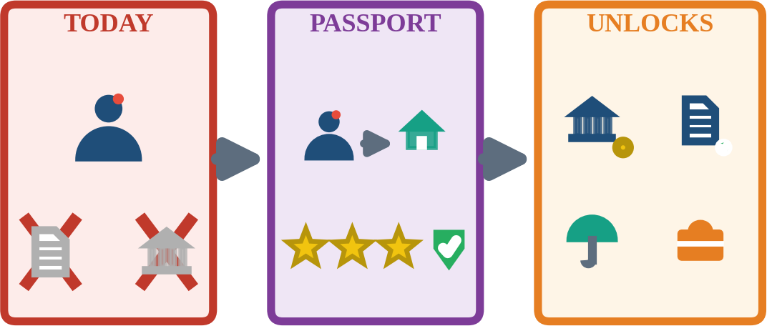

Fig. 1. Concept of the Digital Work Passport: undocumented informal work is converted into verified, portable proof that unlocks credit, scheme entitlements, insurance, and better jobs.
This paper proposes a compact, reproducible, and privacy-aware platform that converts everyday informal work into a verified digital asset. The core contributions of this work are:
- A dual-party verification protocol in which the worker logs a job by voice and the employer confirms through SMS or IVR, requiring no smartphone or literacy on the employer side;

- A transparent five-factor trust-score model with Bayesian rating smoothing, income-stability, consistency, and employer-diversity terms, together with an employer-level collusion index;
- A hash-chained, consent-gated ledger with verifiable-credential export, so that income evidence is portable across lenders and schemes;
- An entitlement-unlock engine mapping the passport to alternative-credit eligibility, scheme matching, pooled insurance, and job matching, aligned with SDGs 1, 5, 8, and 10; and
- A seeded simulation study with sensitivity analysis of participation rates and a candid robustness analysis against collusive fabrication.
The remainder of this paper is organized as follows: Section II reviews related literature; Section III presents the formal problem model; Section IV describes the proposed method; Section V outlines the system architecture and implementation plan; Section
- reports simulation results and sensitivity analyses; and Section
- concludes.

RELATED WORK

Informal Work, Financial Exclusion, and Policy Context
Global surveys consistently show that informal and self-employed women have the lowest access to formal credit and savings instruments, and that the absence of verifiable income is a principal barrier [1], [2]. Policy responses in India include the extension of social-security coverage to gig, platform, and unorganised workers under the Code on Social Security, 2020 [5], and the e-Shram registry [4]. These instruments establish

D. Verifiable Records and Sybil Resistance
The W3C Verifiable Credentials data model standardises tamper-evident, holder-controlled claims [12], and hash-chaining of records, originating with Merkle’s hash-based constructions [13], provides cheap tamper evidence without a heavyweight distributed ledger. Any open attestation system is exposed to Sybil attacks in which one actor operates many fake identities [14]; in our setting this corresponds to rings of colluding “employers” who confirm fictitious jobs, which motivates the employer-behaviour guard of Section IV-D.

E. Voice-First Interfaces for Low-Literacy Users
Text-free interfaces and interactive voice systems have demonstrated usability among semiliterate users in India [15], [16]. Recent multilingual speech recognition models for Indian languages [17] and large-scale weakly supervised recognisers [18] make regional-language voice logging technically feasible, although accuracy on noisy, code-mixed, low-resource speech must be validated in the field.

PROBLEM FORMULATION

System Model and Work Records
Let W be the set of workers and E the set of employers or clients. A work record is a tuple
r = (w, e, o, d, a, g, s) (1)
where w is the worker, e the employer, o the occupation, d the date, a the amount paid, g an optional rating in {1,…,5}, and s the status in {LOGGED, CONFIRMED, DISPUTED, EXPIRED}. A
record becomes CONFIRMED only when the employer
acknowledges it through an independent channel. Time is

entitlement in principle but depend on the worker being able to
document herself; they do not generate the longitudinal work
discretised into M = 12 monthly periods. Let R
w
log and R
w
conf

evidence that lenders and employers require.

Reputation and Rating Systems
Online reputation systems aggregate peer feedback into trust signals [6], and surveys of trust and reputation models describe Bayesian and belief-based aggregation as robust to sparse feedback [7]. Applied to labour platforms, ratings can concentrate power in the platform and can encode bias against workers [8], [9]. Our design therefore uses transparent, explainable score components, a Bayesian prior to prevent a single rating from dominating, and worker-owned data that can be exported rather than locked to one platform.

Alternative Credit Data
Digital footprints and mobile-phone behaviour have been shown to predict repayment for borrowers without credit files [10], [11]. These approaches infer creditworthiness indirectly, which raises
denote the logged and confirmed records of worker w.

Objectives and Constraints
The platform must satisfy four requirements: (1) accessibility, meaning that logging and confirmation require only a basic phone and a regional-language voice or SMS interaction; (2) integrity, meaning that confirmed history cannot be silently altered or cheaply fabricated; (3) privacy, meaning that no third party sees a worker’s data without explicit, revocable consent; and (4) utility, meaning that the record must translate into measurable financial and entitlement outcomes. Formally, the system seeks to maximise the number of genuinely creditworthy workers cleared by the eligibility rule while keeping the fraction of fabricated profiles approved close to zero.

Trust-Score Components
Five normalised components are computed per worker.
Verification ratio:

fairness and consent concerns. Employer-attested income is a more direct and intelligible signal, and it is the signal that a loan officer
V = |R
w
w
conf| / |R
w
log| (2)

would otherwise seek by asking for salary slips that informal workers do not have.
Smoothed rating, with n ratings of mean r̄ , prior mean μ
w w 0
and prior weight m = 5:
= 3.5,

Qw = [ (n r̄ + mμ ) / (n
w
w
0
w
+ m) − 1 ] / 4 (3)

Consistency C = A /M, where A
is the number of months with

w w w

confirmed income; income stability S
w
= max(0, 1 − σ
w
/μw
), the

complement of the coefficient of variation of monthly confirmed
income; and employer diversity Dw = min(1, U /U ), where U is
w
0
w
the number of distinct confirming employers and U0 = 4.

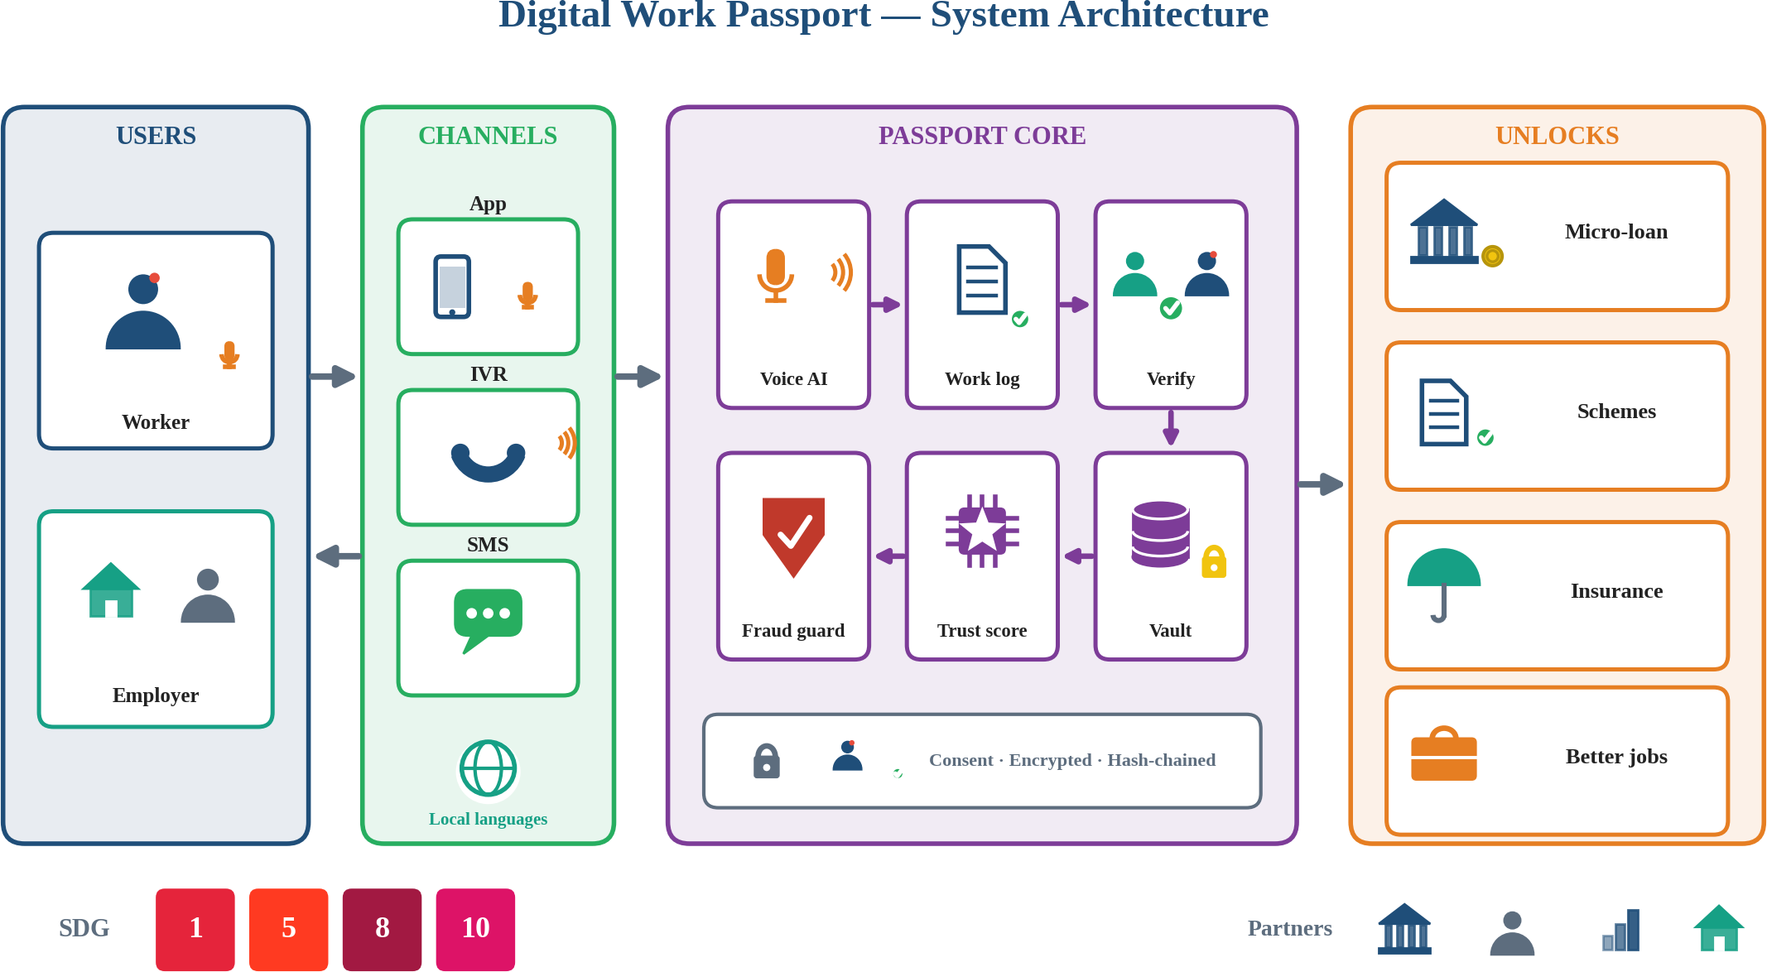

Fig. 2. System architecture of the Digital Work Passport showing the user, channel, passport-core, and entitlement-unlock layers.

Composite Score and Eligibility
The trust score on a 0–100 scale combines the components and is

C. Trust Score Engine
Scores are computed from confirmed records only, using Eqs.

discounted by the collusion share ρ
w
defined in Eq. (7):
(2)–(4). Every component is shown to the worker in plain language

T = 100 (α V
w 1 w
+ α Q + α C
2 w 3 w
+ α S + α D )(1 − ρ
4 w 5 w w
) (4)
and icons (for example, “Employers who vouched for you: 3”), so
that the score is explainable and contestable. Scores are always

with weights α = (0.30, 0.25, 0.20, 0.15, 0.10). Micro-credit eligibility and the indicative limit are:
Elig = 1[T ≥ 55, A ≥ 6, ỹ ≥ 3000, ρ < 0.3] (5)
w
w w w w
accompanied by the underlying verified income record, since lenders need amounts as well as ratings.

D. Collusion Guard

L = min(L , 3ỹ ), L = Rs. 30,000 (6)

where ỹ
w
w cap w cap
is the median monthly confirmed income in Rs. The
To resist fabricated histories, each employer account e receives a suspicion score from three behavioural indicators: confirmation

thresholds are illustrative policy parameters that a partner lender
would calibrate, not learned values.
rate κ , five-star share f , and number of distinct workers served δ :
e e e

se = 0.4·1[κe ≥ 0.9] + 0.3·1[f ≥ 0.85] + 0.3·1[δe ≥ 6] (7)
e

PROPOSED METHOD

Voice-First Work Logging
After a job the worker records a short voice note in her own
An employer with at least four confirmed records and se ≥ 0.6 is marked suspicious. The collusion share of a worker is the fraction
of her confirmed income that originates from suspicious

language (for example, “Cooked at Lakshmi madam’s house, Rs.
employers, ρ
w
= (Σ a
we
over suspicious e) / (Σ a
we
over all e),

1,500”). A speech-recognition and entity-extraction stage proposes the employer, amount, and date, and the app reads the parsed entry back for confirmation, so that errors are caught by ear rather than by reading. The same flow is exposed through IVR for feature phones. Unparsed entries fall back to a guided tap-and-voice form.

Dual-Party Verification
For every logged record, the employer receives an SMS or automated call in her language with a one-key response (confirm, dispute) and an optional 1–5 rating. Confirmation requires no app installation and no account creation. Records not answered within 72 hours expire as unverified and are retained but excluded from income and score. Disputed records are flagged to a grievance workflow that, in a deployment, can be escalated to a partner NGO or worker collective.
which enters Eq. (4) and Eq. (5). Legitimate institutional employers, such as a salon employing many beauticians, trigger only the degree indicator and are not flagged.

E. Entitlement Unlock Engine
A rule engine matches verified attributes (occupation, age band, bank-account status, income band, and state) against machine-readable scheme criteria. In the evaluation it covers three illustrative entitlements: registration on the national unorganised-worker database for workers aged 16–59, PM SVANidhi for street vendors, and bank-linked accident insurance. Eligibility is presented to the worker as a prompt with the required documents listed, and nothing is submitted without her consent.

F. Consent, Privacy, and Portability
The ledger is encrypted at rest and every disclosure to a lender, insurer, or scheme operator is gated by a scoped, time-limited, revocable consent token, consistent with the consent-based processing model of India’s Digital Personal Data Protection Act [19]. Records are appended to a per-worker hash chain, so that any later modification invalidates the chain, and a summary can be exported as a signed verifiable credential [12].
Algorithm 1 summarises the end-to-end pipeline.
Algorithm 1. Passport Update and Eligibility Pipeline

Implementation Plan and Validation
The reference stack is a Python REST backend, a lightweight cross-platform client, a telephony gateway for IVR/SMS, and an open speech-recognition model fine-tuned on regional-language worker speech. Planned validation proceeds in stages: unit and property tests for score monotonicity and ledger integrity; usability trials with workers and employers; adversarial testing of the guard; and a pilot with a partner NGO and one NBFC. At the time of writing, the results of this paper come from the simulation described below; no field data have been collected.

VI. EXPERIMENTS AND RESULTS

Experimental Setup
As no real longitudinal dataset of informal work records exists, we built a seeded synthetic cohort. It comprises N = 2,000 workers over M = 12 months in six occupations (Table I), of whom 10% are fabricators who submit invented histories confirmed by rings of fake employer accounts. For genuine workers, each active month a client pays with probability 0.92; the worker logs the job

with probability p = 0.85 and the employer confirms with
1: INPUT worker w, job events, parameters theta 2: for each job event e of w do
3: r <- VoiceLog(e); r.status <- LOGGED
4: SendConfirmRequest(r.employer, r) # SMS/IVR 5: if confirmed within 72 h then
6: r.status <- CONFIRMED; Append(chain, H(r)) 7: else r.status <- EXPIRED
8: end for
9: Es <- {e : s_e >= 0.6 and n_e >= 4} 10: rho <- CollusionShare(w, Es)
11: T <- TrustScore(R_w, rho)
12: if Elig(w) then offer L_w to lender 13: Entitlements <- RuleMatch(profile(w))
# Eq.7
# Eq.4
# Eq.5-6
14: return Passport(w, T, income, Entitlements)

probability p
log

SYSTEM IMPLEMENTATION

Architecture
The platform is organised in four layers (Fig. 2). The user layer comprises workers and employers. The channel layer offers a regional-language mobile app with voice input, an IVR line for feature phones, and SMS for employer confirmation. The passport core contains the voice-AI service, the work-log service, the verification service, the fraud guard, the trust engine, and the encrypted vault with the hash-chained ledger, all behind a consent gateway. The unlock layer exposes partner-facing APIs for lenders, scheme operators, insurers, and job-matching employers. Stateless REST services and a relational store keep the design deployable on modest infrastructure.

Worker Experience
The worker interface is icon-led and voice-driven: a large microphone button for logging, a passport card showing verified months, income band, and star-based trust, and one-tap sharing of a consented summary with a lender. Prompts and read-back are available in the major Indian languages, selected at onboarding, and the interface avoids numeric jargon. A group mode lets self-help groups and worker collectives onboard members together and manage grievances.

Data Model and Integrity
Each record stores its hash, the previous hash, status transitions, and the confirmation channel and timestamp. Employer identities are bound to verified phone numbers, with rate limits on how many workers one number may confirm per day. Periodic Merkle roots of the ledger can be anchored with a partner for external audit. Raw voice notes are deleted after transcription unless the worker opts in to retain them.
conf = 0.70; ratings are drawn around a latent quality. Fabricators log three records per month at roughly twice a typical
genuine monthly income and receive confirmation from fake employers. Occupation parameters, rates, and attack behaviour are assumptions, so the absolute numbers are illustrative; relative effects and sensitivities are the main findings. The simulation produced 72,991 records. Ground truth “creditworthy” means a genuine worker with at least six truly active months and a true monthly income of at least Rs. 4,000.
TABLE I
SYNTHETIC COHORT PARAMETERS (ASSUMED)

Occupation | Share | Median income (Rs./mo) | Clients / mo
Domestic helper | 34% | 6,000 | 3.0
Cook | 12% | 7,000 | 2.5
Beautician | 12% | 8,000 | 6.0
Tailor | 12% | 6,500 | 5.0
Street vendor | 18% | 5,000 | 3.0
Anganwadi / ASHA | 12% | 5,500 | 1.0 (institution)

Trust-Score Behaviour
Fig. 3(a) shows the score distribution of genuine workers by occupation. Mean genuine score is 66.1 (±0.1 over five seeds). Anganwadi/ASHA workers score lowest because they have one institutional employer, which depresses the employer-diversity component, and a single supervisor’s confirmation affects the verification ratio. This exposes a design limitation: the diversity term should be occupation-aware, a point we revisit in Section VII. Fig. 3(b) shows that without the guard, fabricated profiles earn scores comparable to the top genuine workers, whereas the guard drives them to near zero.

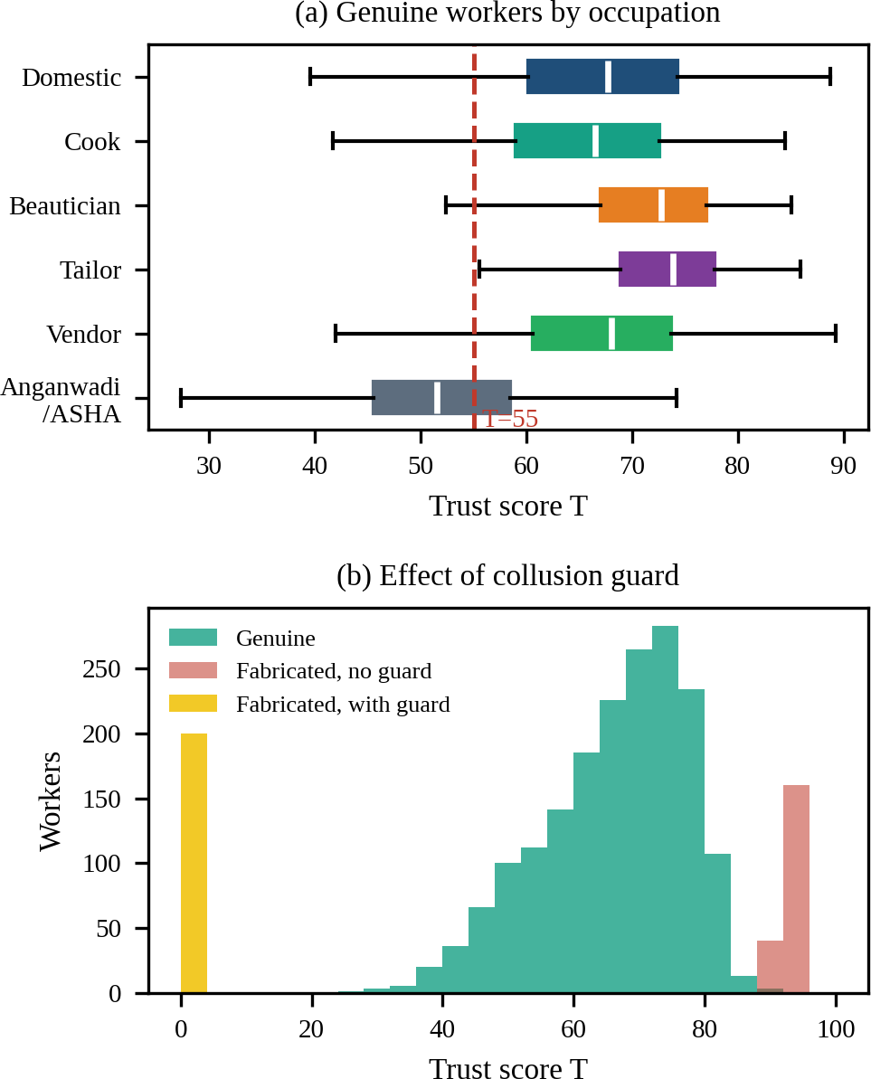
Sensitivity to Participation
Fig. 4(a) varies the employer confirmation rate. The cleared

share is highly sensitive: at p
conf
= 0.3 almost no creditworthy

worker qualifies, while at 0.9 the cleared share reaches 79% for

p
log
= 0.85. A weaker worker logging rate (0.6) lowers the whole

Fig. 3. Trust-score behaviour: (a) genuine workers by occupation with the eligibility threshold; (b) score distributions for genuine and fabricated profiles with and without the collusion guard.

Inclusion Outcomes
curve. Hence the commercial viability of the passport depends on employer participation, which should be treated as a first-order design objective (reminders, simple one-key responses, and incentives) rather than an afterthought.

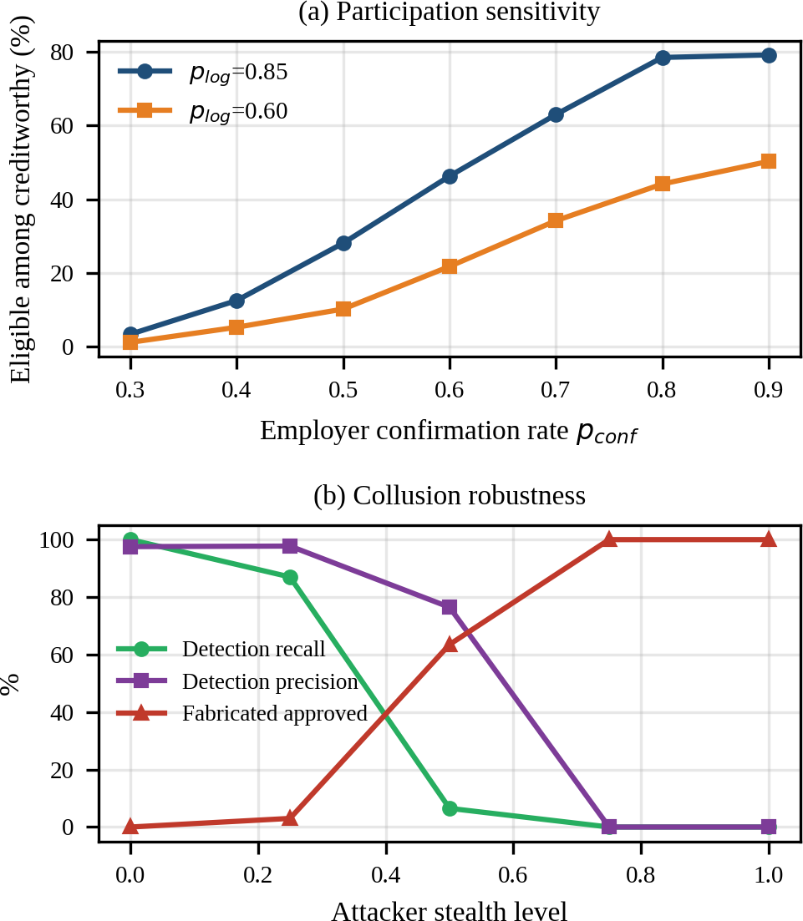
TABLE II
INCLUSION OUTCOMES (SEED 7; NAIVE FABRICATION)
Metric
Status quo (assumed)
Passport, no guard
Passport, full

Income-verifiable genuine workers (%)
Creditworthy workers cleared (%)
Fabricated profiles approved

6.0 90.7 90.7

≤ 6.0 63.2 63.0
Fig. 4. Sensitivity analysis: (a) share of creditworthy workers cleared versus employer confirmation rate; (b) collusion-guard performance versus attacker stealth.

Robustness to Collusion
TABLE III

(%) n/a 100.0 0.0
COLLUSION GUARD VERSUS ATTACKER STEALTH

Table II compares the status quo, the passport without the guard, and the full system. The status-quo figures are assumptions (6% of workers hold formal income proof; 28% awareness of each applicable entitlement), not measurements. With the guard, the platform clears 63.0% of truly creditworthy workers (five-seed mean 63.5% ± 0.9) and approves no fabricated profile under naive collusion, whereas without the guard every fabricated profile is approved and 16.3% of approvals are fraudulent. The asterisk marks an upper bound: entitlement discovery here means rule coverage given verified attributes and does not imply successful enrolment, which depends on scheme operators. The remaining shortfall in credit clearance arises mainly from unconfirmed records, which lower verified income and consistency.
Approved who are fabricated n/a (%) | 16.3 | 0.0 | Stealth | Precision (%) | Recall (%) | Fabricated approved (%)
Entitlements discovered (%) 28.2 | 100.0* | 100.0* | 0.00 | 97.6 | 100.0 | 0.0
Mean indicative limit (Rs.) — | — | 15,050 | 0.25 | 97.8 | 87.0 | 3.0
 |  |  | 0.50 | 76.5 | 6.5 | 63.5

0.75 | 0.0 | 0.0 | 100.0
1.00 | 0.0 | 0.0 | 100.0
Stealth interpolates fake-employer behaviour from blatant (near-certain confirmation with five-star ratings) to realistic (confirmation rate near 75% and varied ratings). Table III shows that the guard is effective against blatant and mildly disguised rings but collapses at moderate stealth, because the behavioural indicators of Eq. (7) no longer separate fake from genuine employers, and the degree indicator alone is deliberately insufficient to avoid penalising legitimate institutions. We report this as a genuine limitation: a deployed system must add independent evidence, such as matching confirmed income against UPI or bank-credit trails, employer-side identity verification,

graph-based ring detection, and per-employer confirmation quotas.

Limitations
The study is simulation-only with assumed parameters; real confirmation behaviour, voice-recognition accuracy on noisy regional speech, and employer willingness are unknown. The trust score has not been validated against actual repayment, and fairness across occupations and communities requires auditing, particularly given the single-employer penalty above. Digital exclusion of workers without phones, and power asymmetry whereby employers may decline to confirm, are social risks that technology alone cannot remove.

VII. CONCLUSION AND FUTURE WORK
We presented the Digital Work Passport, a voice-enabled framework that turns undocumented informal work into verified, portable, consent-controlled evidence, with an explainable trust score, a collusion guard, and an entitlement-unlock engine aimed at SDGs 1, 5, 8, and 10. In a seeded simulation of 2,000 workers, the platform made over 90% of genuine workers income-verifiable and cleared roughly 63% of creditworthy workers for micro-credit at a 70% employer confirmation rate, with no naive fabricated profile approved. The analysis also shows that results hinge on employer participation, that single-employer occupations are disadvantaged by the current diversity term, and that a behaviour-only guard is not enough against stealthy collusion.
Future work will pilot the system with an NGO and an NBFC to replace assumed parameters with field measurements; fine-tune and evaluate regional-language speech recognition on real worker audio; add payment-trail cross-checks and graph-based fraud detection; make the score occupation-aware and audit it for fairness; validate it against repayment; and integrate with scheme portals and the e-Shram registry.

REFERENCES
- International Labour Organization, Women and Men in the Informal Economy: A Statistical Picture, 3rd ed. Geneva, Switzerland: ILO, 2018.
- A. Demirgüç-Kunt, L. Klapper, D. Singer, and S. Ansar, The Global Findex Database 2021: Financial Inclusion, Digital Payments, and Resilience in the Age of COVID-19. Washington, DC, USA: World Bank, 2022.
- Ministry of Housing and Urban Affairs, “PM Street Vendor’s AtmaNirbhar Nidhi (PM SVANidhi) scheme guidelines,” Government of India, New Delhi, India, 2020.
- Ministry of Labour and Employment, “e-Shram: National database of unorganised workers,” Government of India, New Delhi, India, 2021.
- Government of India, “The Code on Social Security, 2020,” Gazette of India, 2020.
- P. Resnick, K. Kuwabara, R. Zeckhauser, and E. Friedman, “Reputation systems,” Commun. ACM, vol. 43, no. 12, pp. 45–48, 2000.
- A. Jøsang, R. Ismail, and C. Boyd, “A survey of trust and reputation systems for online service provision,” Decis. Support Syst., vol. 43, no. 2,
pp. 618–644, 2007.
- A. Rosenblat and L. Stark, “Algorithmic labor and information asymmetries: A case study of Uber’s drivers,” Int. J. Commun., vol. 10,
pp. 3758–3784, 2016.
- A. Hannák et al., “Bias in online freelance marketplaces: Evidence from TaskRabbit and Fiverr,” in Proc. ACM CSCW, 2017, pp. 1914–1933.
- T. Berg, V. Burg, A. Gombović, and M. Puri, “On the rise of FinTechs: Credit scoring using digital footprints,” Rev. Financ. Stud., vol. 33, no. 7,
pp. 2845–2897, 2020.
- D. Björkegren and D. Grissen, “Behavior revealed in mobile phone usage predicts credit repayment,” World Bank Econ. Rev., vol. 34, no. 3, pp. 618–634, 2020.
- World Wide Web Consortium, “Verifiable Credentials Data Model v1.1,” W3C Recommendation, 2022.
- R. C. Merkle, “A digital signature based on a conventional encryption function,” in Advances in Cryptology—CRYPTO ’87, LNCS 293. Berlin, Germany: Springer, 1988, pp. 369–378.
- J. R. Douceur, “The Sybil attack,” in Peer-to-Peer Systems (IPTPS 2002), LNCS 2429. Berlin, Germany: Springer, 2002, pp. 251–260.
- I. Medhi, A. Sagar, and K. Toyama, “Text-free user interfaces for illiterate and semiliterate users,” Inf. Technol. Int. Dev., vol. 4, no. 1, pp. 37–50, 2007.
- N. Patel et al., “Avaaj Otalo: A field study of an interactive voice forum for small farmers in rural India,” in Proc. ACM CHI, 2010, pp. 733–742.
- T. Javed et al., “Towards building ASR systems for the next billion users,” in Proc. AAAI Conf. Artif. Intell., vol. 36, 2022.
- A. Radford et al., “Robust speech recognition via large-scale weak supervision,” in Proc. Int. Conf. Mach. Learn. (ICML), 2023.
- Government of India, “The Digital Personal Data Protection Act, 2023,” Gazette of India, 2023.

